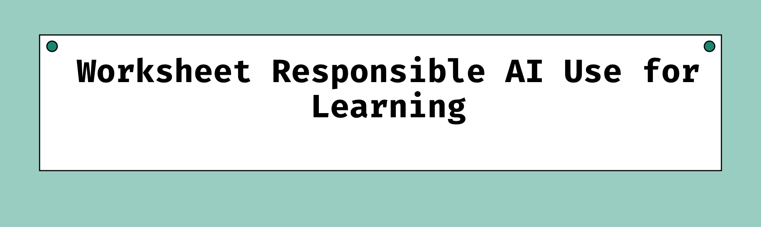
Name:
Module/Course:
Assessment or Topic:
Date:
Before You Use AI
Do
  - Read the assessment brief, rubric, and AI-use instructions.
  - Decide what you need help with before writing a prompt.
  - Use AI to support your thinking, not to replace it.
  - Use specific prompts and ask follow-up questions.
  - Keep a record of how you used AI if disclosure is required.
Don’t
  - Do not submit AI-generated work as if it is entirely your own.
  - Do not paste confidential, personal, sensitive, or unpublished information into an AI tool.
  - Do not assume an answer, fact, quotation, citation, or reference is correct.
  - Do not use AI where your lecturer, institutional or assessment rules do not allow it.
  - Do not allow AI to make your final academic decisions.
Quick Check
I know what AI use is permitted for this task.
I have a clear learning purpose for using AI.
I will protect private and confidential information.
I will verify AI outputs before relying on them.

AI for Research
Do
  - Ask AI to help refine a broad topic into research questions.
  - Ask for search terms, synonyms, and database keywords.
  - Use library databases and credible academic sources to find evidence.
  - Read the original source before citing or using it.
  - Check authors, publication dates, publishers, evidence, and relevance.
Don’t
  - Do not cite an AI tool as though it were the original academic source.
  - Do not use references suggested by AI without confirming that they exist.
  - Do not use a source you have not opened and read yourself.
  - Do not copy statistics, quotations, or claims without checking the original publication.
Research Verification Checklist
I found the original source myself.
The author or organisation is credible.
The publication is relevant to my topic and current enough for my task.
I read the source, rather than relying only on an AI summary.
I checked that the source supports the claim I am making.
I checked all quotations, data, and statistics against the original source.
My in-text citations and reference-list entry are accurate.
I can explain why this source is credible.
Source checked:
How it supports my work:
Prompt Starter
“My research topic is [topic]. Help me generate focused research questions and search keywords for academic databases. Do not provide or invent sources.”

AI for Study Support
Do
  - Ask AI to explain difficult concepts in simpler language.
  - Ask for an example, analogy, comparison, or practice scenario.
  - Use quizzes and short-answer questions to practise recall.
  - Ask for Socratic questioning: one question at a time, with feedback after your answer.
  - Return to your notes, textbook, lecture materials, and credible sources to confirm learning.
Don’t
  - Do not passively accept an explanation because it sounds convincing.
  - Do not use AI summaries as a replacement for reading required material.
  - Do not ask AI to provide answers to tests or assessments where this is not allowed.
  - Do not rely on AI alone when you are confused - seek help from your lecturer, tutor, or academic-support service.
Study Support Verification Checklist
I can explain the concept in my own words.
I checked the explanation against course materials.
I identified any unclear, inaccurate, or incomplete AI output.
I practised retrieving information without looking at my notes.
I completed at least one application question, scenario, or case study.
I know what I need to revise next.
I know where to get human support if I remain unsure.
Concept I am studying:
Explain it in my own words:
Prompt Starter
“I am studying [topic]. Quiz me using Socratic questioning. Ask one question at a time, wait for my response, then explain any misunderstanding before continuing.”

AI for Essay and Assessment Writing
Do
  - Use AI to brainstorm possible approaches, arguments, or structures.
  - Ask for feedback on clarity, paragraph flow, and argument gaps.
  - Use editorial tools to identify grammar, punctuation, and tone issues.
  - Compare your draft against the assessment question and marking rubric.
  - Revise the work yourself using your own judgement and evidence.
Don’t
  - Do not ask AI to write the assessment for you.
  - Do not copy and paste AI-generated paragraphs into your submission.
  - Do not use AI feedback without considering whether it fits your discipline, task, or rubric.
  - Do not let AI create or verify references without independently checking them.
  - Do not replace lecturer, tutor, peer, or academic-support feedback with AI feedback.
Prompt Starter
“Review this draft for clarity, structure, and logical flow. Identify one gap in my argument and ask questions that will help me improve it. Do not rewrite the assignment for me.”

Final Check
- Before you finish, ask yourself:
- Did AI support my learning rather than do the learning for me?
- Did I verify important information using credible original sources?
- Did I protect private, confidential, and sensitive information?
- Did I follow my course and institution’s AI-use rules?
- Can I explain and defend the work in my own words?
Responsible AI use depends on active human oversight, critical evaluation, academic integrity, and careful treatment of privacy and data.

